**Experiment-1.1**

**Student Name: UID:**

**Branch: Section/Group:**

**Semester: Date of Performance:**

**Subject Name: Subject Code:**

1. **Aim:**
2. **Objective:**

1. **Script and Output:**

* **Arduino**

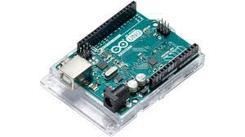

* **Raspberry pi**

